C:\Users\syadavg>rfagent -a 192.168.180.55 -p 1471

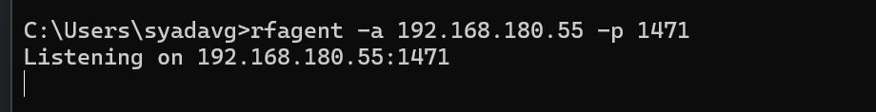

Opened another command prompt window

rfremoterun 192.168.180.55:1471 "C:\Users\syadavg\PycharmProjects\New_Folder\oneautomation\sample_keywords_templates\saleforce_object_scenarios\CRUD_operations\salesforce_objecdts_specific_keywords_test_cases\accounts_scenarios_specific_keywords.robot"

* I have downgraded robot framework to 6.0 since I was getting this below warning

13

Warning is not coming but permission error is coming

* I have given full host address including port then also I am getting the same permission error

(rfremoterun 192.168.180.55:1471 "C:\Users\syadavg\PycharmProjects\New_Folder\oneautomation\

sample_keywords_templates\saleforce_object_scenarios\CRUD_operations\salesforce_objecdts_specific_keywords_test_cases\accounts_scenarios_specific_keywords.robot")

SSH process